Meeting notes 12
First meeting week 12: 2/05/2025
People present: everyone
Supervisors: Bert and Dries

Todo’s
- Cohesive fonts
- Make nice game logo > one that integrates the grandma designs, something with the grandmas in there, with the ball of yarn
- Add shrubs to background of windows
- Delete post process
- Change local exposure to make cafeteria more visible
- Fake godrays at the end, add window situation
- Make sure movement rfx are implemented and others as well
- Turn off distance shader in cutscene
- Make grandma textures to either have the rma material, or get rid of the displacement in the claymation shader
- Figure out group name: Devvy Grannies
- Make tv better
- Put embroidery around
- Redo join ui buttons and adjust saturation so that only the focus
- Turn head of grandma 45 degrees, and do animation twice for when you’re turned around
- Make sure the hair and accessories are attached to the grandma and that the animations work
- Handpin should go through pickups
- Material of item billboards needs to be changed
- Adjust size of item through the texture, only umbrella
- Adjust name from rose to ruth and redo names, no initials, only names
- Make sure player icons are not pixelated
- Make voicelines and announcer be a grandma
- Make sure player icons are turned to the inside for player 2 and 4
- Set up precompiled visibility

Preparing presentation
Frey presents the project
Steven narrates while others show off gameplay
Roeland’s computer, Adam’s computer for backup

Friday, meeting at 8:50 for beamer test, KWEP -1.009
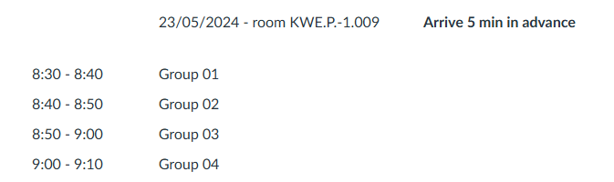
Deadline 10pm for safety build
Saturday, meeting at 14:00, frey’s place: recording voice lines, recording presentation footage, sitting together to organise presentations
Sunday: make final build, finalise presentations
Deadline 8pm for final build
Monday, meeting at 9:30 for presentation, KWEP -1.009
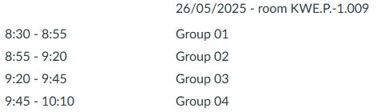
We are dressed like grandmas!!!!

Feedback supervisors
- Make sure devlog has images on there to show what we did
- Make sure all source files are on perforce, and that it’s clean like naming conventions etc.
- Make sure hacknplan is in order
- You can still use the menu when you have the credits selected
- Delete the sphere collision of the ball of death
- Make player faster
- Make game a bit easier
- Make brightness of the platforms better
- Make jump more responsive
- Lower the camera shake a little bit
- Make cutscene not phase through assets

First meeting week 12: 2/05/2025
People present: Adam, Igor, Steven, Frey, Roeland
Supervisors: none

Discussed
- Playtesting
- Planning
- UI adjustments
- Player experience

